SIMATS ENGINEERING (SAVEETHA SCHOOL OF ENGINEERING)
Department of Computer Science and Engineering

ASSESSMENT TOOL 2 – Industry Problem Solving Task

Course Code: | CSA06 | Course Title: | Design and Analysis of Algorithms
CO Assessed: | CO4: Articulation (BL4, BL5) | Assessment: | Assessment Tool 2 – Industry Problem Solving Task
Weightage: | 20% of CIA | Total Marks: | 100
CO4 Statement: | Solve optimization problems using dynamic programming and greedy strategies.
Student Name: | G Durga Surya Prasad | Reg. No.: | 192425158
Section / Batch: | Slot c | Date: | 22-08-26

Instructions to Students
- Answer the following question. Total Marks: 100.
- Carefully analyze the given questions.
- Explain in detail with sample code if needed.
- Clearly identify all key issues.
- Provide a thorough analysis with validated results and performance evaluation.

Question Type | Focus Area | Questions
Industry Problem Solving Task | Focus on Solving optimization problems using dynamic programming and greedy strategies | Q1

SECTION A – Industry Problem Solving Task

Q11. Cloud Resource Allocation Optimization (Knapsack Model)
A cloud service provider must allocate limited server memory (120 GB) among multiple enterprise
applications, each with different resource demands and revenue contributions. Analyze how this allocation
problem can be modeled using the 0/1 Knapsack algorithm to maximize overall profit. Identify constraints
such as service-level agreements, workload fluctuations, and priority handling. Design a feasible solution
using dynamic programming and justify the use of optimal substructure and overlapping subproblems.
Discuss how the model can be extended for real-time cloud environments. Analyze time and space
complexity and interpret performance in a scalable industry scenario.

Aim
To model the cloud resource allocation problem using the 0/1 Knapsack algorithm and Dynamic Programming, in order to maximize the total revenue obtained from allocating limited server memory of 120 GB among multiple enterprise applications.
Problem Statement
A cloud service provider has a limited amount of server memory, 120 GB, which must be allocated among several enterprise applications. Each application requires a specific amount of memory and provides a certain revenue when selected.
The objective is to select a combination of applications such that:
- The total allocated memory does not exceed 120 GB.
- The total revenue is maximized.
- Each application is either selected or not selected, so the problem follows the 0/1 Knapsack model.
- Service-Level Agreements (SLAs), workload fluctuations, and application priorities must be considered while making the allocation.
Dynamic Programming is used because the problem has optimal substructure and overlapping subproblems.
Sample Input
Assume the cloud provider has the following applications:
Application | Memory Required (GB) | Revenue
Application 1 | 20 | 40
Application 2 | 30 | 50
Application 3 | 40 | 70
Application 4 | 50 | 80
Application 5 | 60 | 90

Maximum Server Memory = 120 GB
Algorithm
- Start the program.
- Read the number of applications n.
- Read the memory requirement of each application.
- Read the revenue contributed by each application.
- Read the maximum available server memory W = 120.
- Create a DP table dp[n+1][W+1] and initialize it with zero.
- For every application, consider all possible memory capacities from 0 to W.
- If the memory requirement of the current application is less than or equal to the current capacity:
  - Calculate the profit by including the application.
  - Calculate the profit by excluding the application.
  - Store the maximum of the two values.
- If the application cannot fit in the current capacity, copy the previous value.
- After completing the DP table, dp[n][W] gives the maximum possible revenue.
- Trace the DP table backwards to identify the selected applications.
- Calculate the total memory used.
- Display the selected applications, total memory used, and maximum revenue.
- Stop the program.
Code:
def cloud_resource_allocation(memory, revenue, capacity):
n = len(memory)

# DP table
dp = [[0] * (capacity + 1) for _ in range(n + 1)]

# Fill DP table
for i in range(1, n + 1):
for w in range(1, capacity + 1):

if memory[i - 1] <= w:
include = revenue[i - 1] + dp[i - 1][w - memory[i - 1]]
exclude = dp[i - 1][w]

dp[i][w] = max(include, exclude)
else:
dp[i][w] = dp[i - 1][w]

# Find selected applications
selected = []
w = capacity

for i in range(n, 0, -1):
if dp[i][w] != dp[i - 1][w]:
selected.append(i)
w -= memory[i - 1]

selected.reverse()

total_memory = sum(memory[i - 1] for i in selected)
maximum_revenue = dp[n][capacity]

return selected, total_memory, maximum_revenue

# Input data
memory = [20, 30, 40, 50, 60]
revenue = [40, 50, 70, 80, 90]
capacity = 120

selected, total_memory, maximum_revenue = \
cloud_resource_allocation(memory, revenue, capacity)

print("CLOUD RESOURCE ALLOCATION OPTIMIZER")
print("------------------------------------")
print("Server Memory Capacity:", capacity, "GB")

print("\nSelected Applications:")
for app in selected:
print("Application", app)

print("\nTotal Memory Used:", total_memory, "GB")
print("Maximum Revenue:", maximum_revenue)
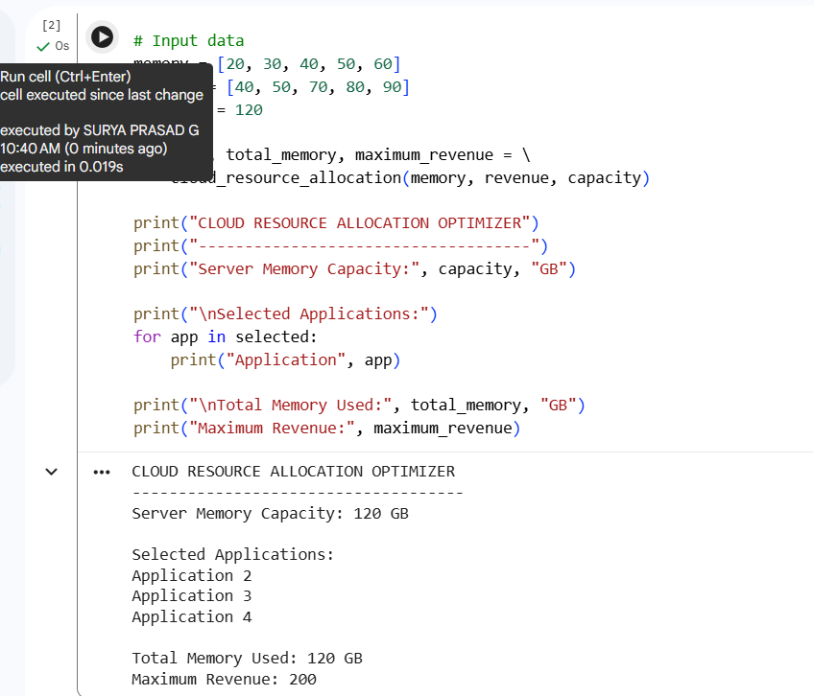

Why 0/1 Knapsack is Suitable
The 0/1 Knapsack algorithm is suitable because each enterprise application has two possible decisions:
- 1 → Allocate resources to the application
- 0 → Do not allocate resources to the application
An application cannot be partially selected or selected multiple times in the basic model.
The objective is to maximize revenue while keeping the total memory allocation within the available 120 GB.
Optimal Substructure
The problem has optimal substructure because the optimal allocation for a particular number of applications and memory capacity can be constructed from optimal solutions of smaller application sets and smaller memory capacities.
For example, when deciding whether to allocate memory to Application 4, the solution depends on the best allocation obtained for the remaining applications and remaining memory.

Overlapping Subproblems
The same smaller allocation problems are encountered repeatedly while considering different applications and memory capacities.
Dynamic Programming stores these previously calculated results in the DP table, avoiding repeated computation and improving efficiency.
Time Complexity
For n applications and capacity W:
Time Complexity = O(n × W)
For the given example:
n = 5
W = 120
Operations ≈ 5 × 120 = 600
The algorithm is efficient for moderate numbers of applications and resource capacities.
Space Complexity
Using a two-dimensional DP table:
Space Complexity = O(n × W)
For the given problem:
Space = 5 × 120
Conclusion
The 0/1 Knapsack Dynamic Programming approach provides an effective method for optimizing cloud resource allocation. It considers each application only once and determines whether allocating resources to that application increases the overall revenue.
The use of optimal substructure and overlapping subproblems makes Dynamic Programming suitable for solving this optimization problem efficiently. In real-time cloud environments, the model can be extended by incorporating workload fluctuations, SLA requirements, application priorities, and dynamic resource availability.

Code of Conduct
I G Durga Surya Prasad (192425158) certify that this submission is my original work and that I have adhered to the guidelines specified for this assessment. I understand that any violation of academic integrity rules will result in disciplinary action.
Signature of the Student: __G Durga Surya Prasad_______________________

RUBRICS FOR CALCULATION

Industry Problem Solving Task

Criteria | Weightage | Level 4 – Exemplary | Level 3 –  Proficient | Level 2 –  Developing | Level 1 –  Beginning
Understanding of  Industry Problem | 20% | Comprehensive understanding of  real-world problem and constraints | Good understanding with minor gaps in requirements | Basic understanding; some  requirements unclear | Poor understanding; misinterprets problem context
Application of  Engineering  Concepts | 25% | Applies advanced and relevant concepts  effectively to solve the problem | Applies appropriate  concepts with minor errors | Limited application of concepts | Incorrect or no application of concepts
Solution Design | 25% | Innovative, practical, and feasible solution  aligned with industry standards | Logical and feasible solution with minor gaps | Basic solution with limited feasibility | Unclear or impractical solution
Use of Tools | 15% | Effective use of modern tools,  technologies, and real  data | Appropriate use of tools with correct implementation | Limited or inconsistent use of tools | Minimal or incorrect use of tools
Analysis | 10% | Thorough analysis with validated results and performance evaluation | Good analysis with reasonable validation | Basic analysis with limited validation | Poor or no analysis
Professionalism | 5% | Highly professional, well-documented,  and clearly presented  work | Good documentation and presentation | Basic documentation with some gaps | Poor documentation and presentation

Marks Evaluation:
Criteria | Wt. | Level 4 –  Exemplary | Level 3 –  Proficient | Level 2 –  Developing | Level 1 –  Beginning
Understanding of Industry Problem | 20%
Application of Engineering Concepts | 25%
Solution Design | 25%
Use of Tools | 15%
Analysis | 10%
Professionalism | 5%
Total Marks (100):

Faculty In-charge | Course Coordinator | Head of Department
Name: | Name: | Name:
Signature: _______________ | Signature: _______________ | Signature: _______________
Date: ___________________ | Date: ___________________ | Date: ___________________

